Annual Report

St Andrews Environmental Network Ltd

Year 2019/20

St Andrews Environmental Network was established in 2010 by the Royal Burgh of St Andrews Community Council to deliver a one-year energy project. We have come along way since then and are now a Limited Company with Charitable status delivering a range of Environmental Projects, many in partnership with other likeminded organisations.

In 2010 the organisation had one full-time member of staff and four part-time staff, this has grown to 6 full-time staff, 3 part-time staff and 7 volunteers. We are always looking for more volunteers to help with a variety of projects.

Funding is always an issue with 99% of our funding coming from grants. Our aim is to move away from this situation and develop some new projects that generate an income for the organisation. The biggest barrier to this is the need for premises. Fife Council have informed us that they are closing the offices located at St Mary’s Place St Andrews – date unknown as a result the organisation has lodged an application to acquire the building under community asset transfer. Having more space would also allow us to increase our administration volunteering opportunities as these are very restricted at present due to the size of our current office. As part of the application for the community asset transfer we prepared a business plan outlining our use of the building as an eco-hub for St Andrews.

This year we have built up our following on Facebook and have started using instagram

The objects of the Company are:

to advance health and wellbeing by tackling the causes of fuel poverty and reducing energy bills for residents and businesses in the Operating Area;

to promote and support the reduction of the carbon footprint of the Operating Area;

to advance environmental protection and improvement by improving energy efficiency within the Operating Area;

to advance education on environmental issues and energy efficiency, particularly among the residents and businesses of the Operating Area; and

to advance citizenship or community development (including the promotion of civic responsibility, volunteering and the voluntary sector).

Our main projects were:

Community Share for Climate Care, a two-year Climate Challenge Fund project in partnership with Transition University of St Andrews and St Andrews Botanic Garden. As part of this partnership we have developed a community site at the back of the Botanic Garden known as the Kernel.

Cosy Kingdom, an energy advice project in partnership with Greener Kirkcaldy and Citizens Advice and Rights Fife. Greener Kirkcaldy are the lead partner in this project and receive funding from Fife Council for the project.

Clean & Green, an environmental project to improve the appearance of the town of St Andrews with attention to the BID area as they are the major funder.

Towards a Plastic Free St Andrews, in partnership with the University of St Andrews and Transition University of St Andrews we have developed a strategy to move St Andrews away from single use plastic. This initiative is currently unfunded.

Below is a summary of each of the projects listed above;

Community Share for Climate Care, has come to the end

Headline Achievements
- 841tCO2e saved over 2 years
- Increased harvest from Community Harvest to 1.3 tonnes
- Logged over 3000 volunteer hours per year
- Fixed over 1200 bikes
- Held over 600 project events
- Held 15 Climate Conversation workshops for 93 people
- Increased household goods being re-use to 15 tonnes per year
- 665 tCO2e for the project and 2,204 tCO2e life-time energy savings

StAndEN delivered 3 eliments of this partnership project.

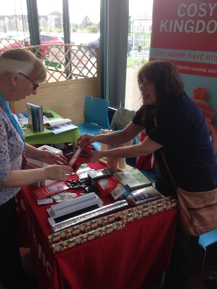
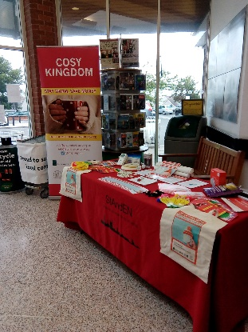
Energy reduction, from April 2019 to March 2020 we held 51 events/workshops giving general energy advice to over 1500 households. Of these 458 households received in depth energy advice tailored to their own circumstances. This was made up of those attending workshops and those who asked for more specific advice after receiving general advice.
For advice to be classed as in-depth it must be either given to an individual, deals with one or more specific topics and capable of resulting in quantifiable energy savings or given at a workshop lasting more than 90 minutes
Events were held at various locations including the local job clubs, the North East Fife Community Hub, Morrisons, St Andrews Hospital and the Cosmos centre. More focused workshops were given to groups and organisations like Home Start, and the Elderly forum. The energy saving skill shares were moved to being held in homes making them much more relevant and the advice became more in-depth as we were able to demonstrate things in a home environment.
A further 337 clients received home visits covering a range of issues how to reduce energy in the home to specific advice on how to get the best use of their heating system to were renewable technologies a good option for them. Each household was left with a detailed energy plan to follow based on the advice given at the visit.
Moving to a green supplier was discussed with clients and many said that this was now something they would consider next time they were going to switch
We held an event for local businesses on 24th January 2019 in Parliament Hall focusing on Switching Energy Supplier and using the savings to improve the energy efficiency of the business. We had representatives from Citrus Energy for Business and Resource Efficient Scotland.
Over the two years of the project the majority of the savings (estimated at 665 tCO2e for the project and 2,204 tCO2e life-time savings) came from behavioural changes which highlights the amount of energy people waste in the home. Simple changes like using your heating controls properly, turn off items on standby and rethinking how we wash our clothes can have outstanding results.
Fewer people made physical change to their properties like up grading boilers or controls and two installed renewable technologies. Some of the 337 clients who received home visits received more than one visit to help then on their carbon reduction journey.
147 households reported that they had switched to a green energy supplier and when asked what the main reason for their choice was 72% felt that climate change was their main driver.

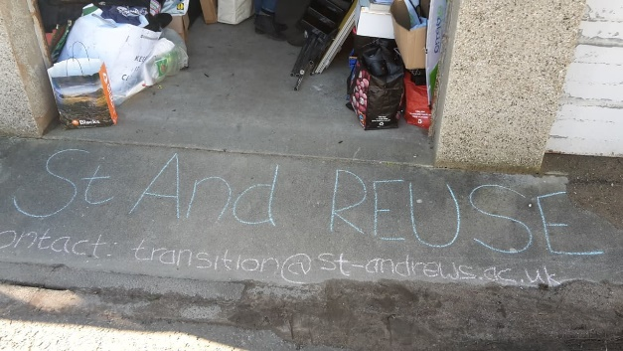
StAnd Reuse, launched as a student initiative in 2009, aims to divert resource from landfill and support the local community to swap, share and reuse a wide range of second-hand items. Through this project, Transition coordinated with the University’s halls of residence and partner organisations to deliver on an end-of-term reuse effort. Students are given the opportunity to donate unwanted belongings which are then sorted and redistributed to students, staff, local residents and charities. In 2017 St Andrews Environmental Network ran a project called StAnd Reuse Town collecting from Students in the private rented sector and residents form the town. From the outset of this project these two projects have been treated as one and have formed a partnership.
In 2019/20, St And Reuse has expanded to cover the partnering organisations in the end-of-term reuse, including, the St Andrews Environmental Network (StAndEN), Clean and Green, St Can-drews and the British Heart Foundation (BHF). Instead of being a solely Transition owned project, St And Reuse is increasingly becoming a town-wide initiative. Along with the 33 tonnes of clothes donated to BHF, St And Reuse has saved some 700 tonnes of CO₂e in the past year alone. And along with Clean and Green transporting donated goods to charities across Fife, we are reaching farther afield than before. St Andrews Environmental Network is looking to further expand this project to include a repair element and open it up to household furniture. Options for funding the start up of StAnd Reuse & Repair are currently being sought.
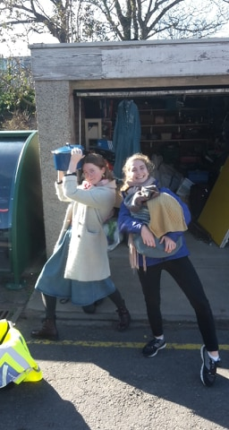
As part of the annual operation of St And Reuse, runs a series of free giveaways including the single biggest one during Freshers Week, attended by some 600-1000 people. The partnership also run weekly drop-in volunteer sessions, which are an opportunity for people to donate and collect reuse goods throughout the year. Each year the partnership has held a give away events during pass it on week.
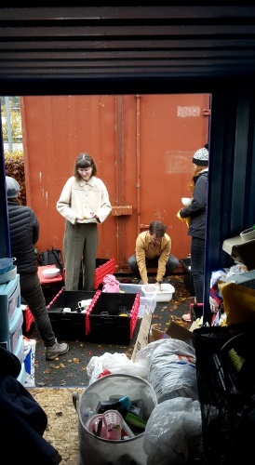
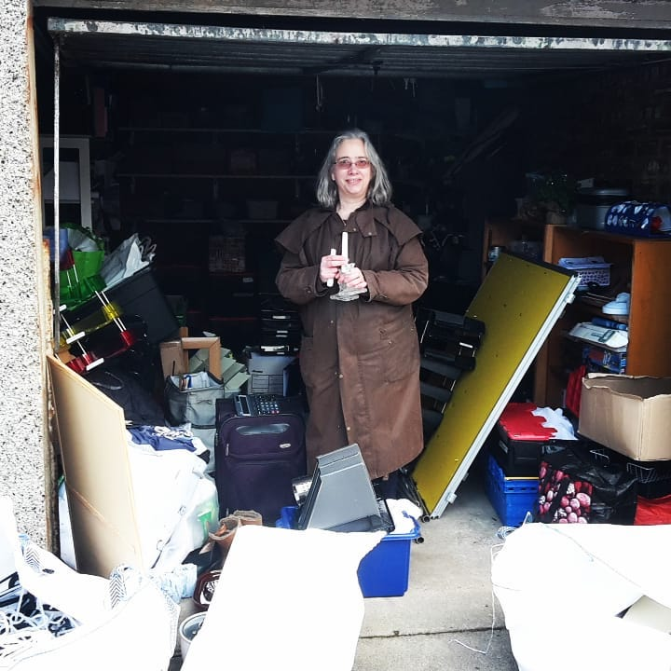

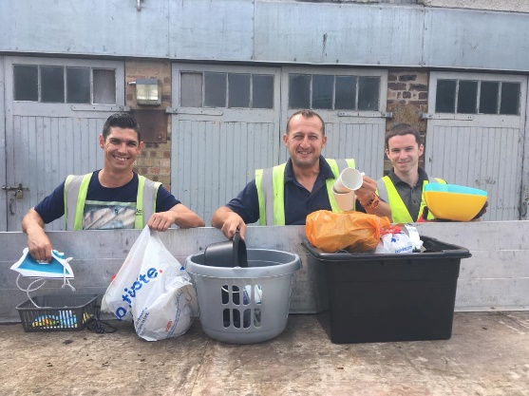
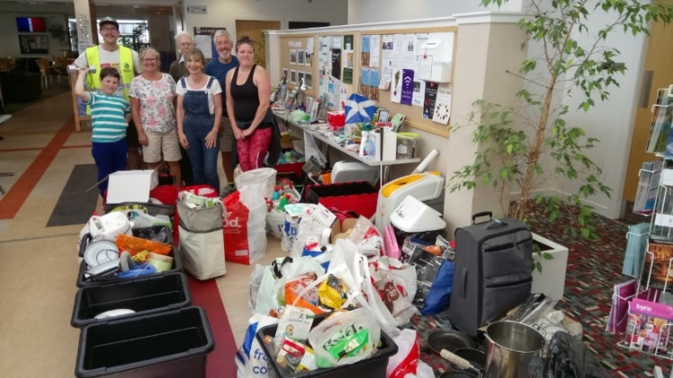

Carbon Conversations Schools was a series of interactive workshops covering Climate Change, Energy, Food and Water, Transport and Waste delivered to year 5 in Madras College. We envisaged it continuing in that format for the 2 years of this project however due to a change in personnel in the school it changed after the first year. The idea for this element was to raise awareness of Climate Change and improve the Carbon Literacy of children before the leave school to empower them to make better life choices going forward.

Activity
In year 1 we delivered the programme of workshops throughout November and December.
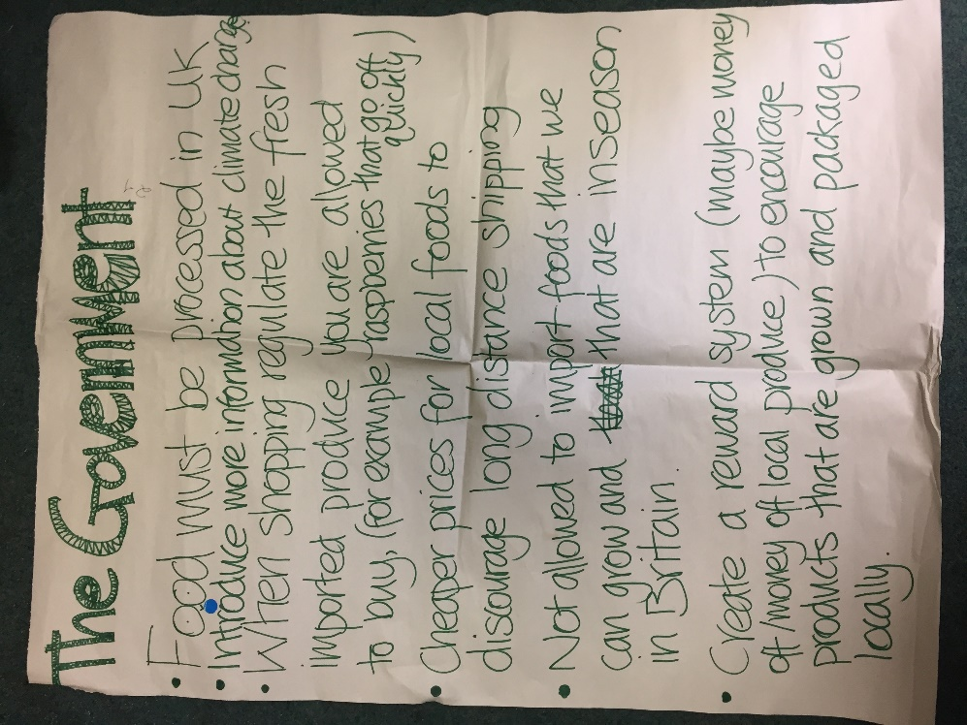
The sessions were delivered November and December to 162 pupils and collected feedback from them. The feedback was very positive about the presentations with 26% finding the Energy Sessions most interesting closely followed by Transport at 25%. During the sessions pupils were asked to split into focus groups and discuss the issues relating to the topics. Each focus group then fed back to the whole class. A summary of their work is being sent as a separate document along with this report. We will the information we have collated form them at meetings with local stakeholders over the coming months.
The school had just introduced recycling bins and we encouraged the pupils to bring back any cans and bottles they bought at lunchtime and put them in the recycling bins rather than the public waste bins in the town which all go to landfill. The school reported a marked increase in the amount of recycled waste over the next few weeks.
While we were delivering the sessions, we were also asked to arrange a beach clean for pupils and this took place on Sunday 25th November
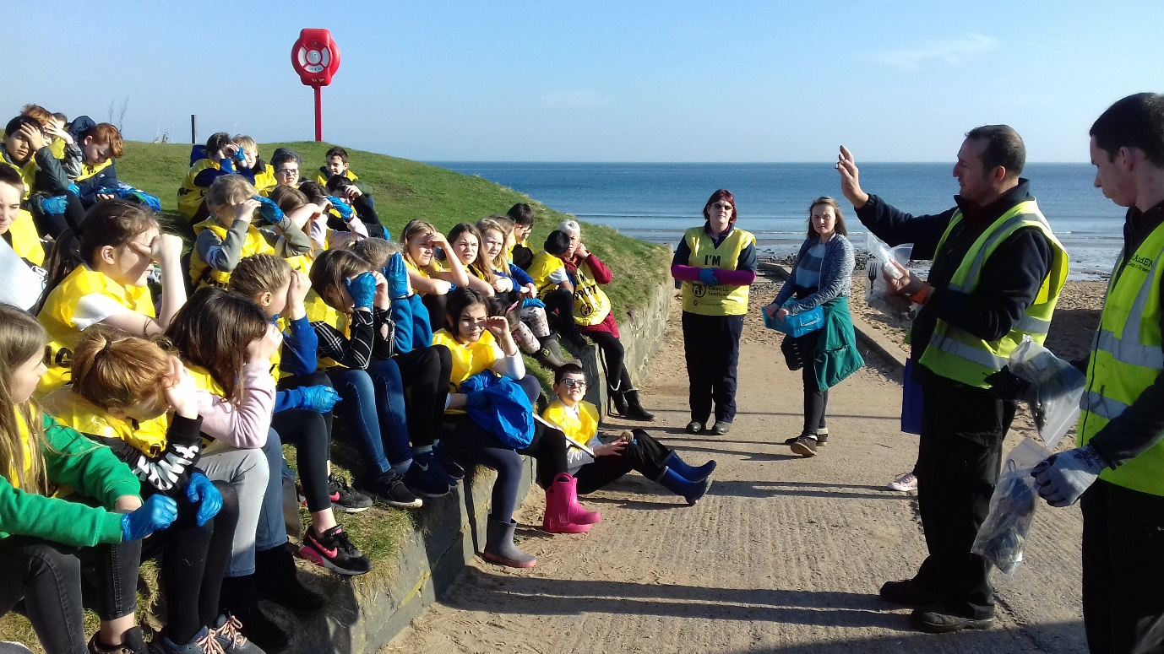
In year 2 because of the change in personnel and scheduling issues the course did not go ahead. This was very disappointing however we carried out sessions in the primary schools which involved a litter pick on the beach and a follow up session in the school talking about plastic pollution. Before the litter pick started the children where shown examples of plastic pollution which had previously collect on the beach and examples of nurdles.

Students pledged to act to reduce their carbon footprint and we followed up to confirm they carried out their pledges. Some of the students added additional actions for later life, for example - when buying properties in the future I will look at the EPC and carry out the recommendations on it, or when I’m earning, I will buy an electric car. We take this as a sign that they are more committed to taking action on climate change than those we dealt with in previous years.
On Sunday 25th November 2018 pupils managed to pick up 17.25kg of waste from the East Sands in ¾ of an hour on a really wet and windy day.
A summary of the actions recommended by the students was sent to Fife Council to feed into the plan for North East Fife.
We re-introduced the primary school programme and had some very good sessions on plastic pollution.

Cosy Kingdom
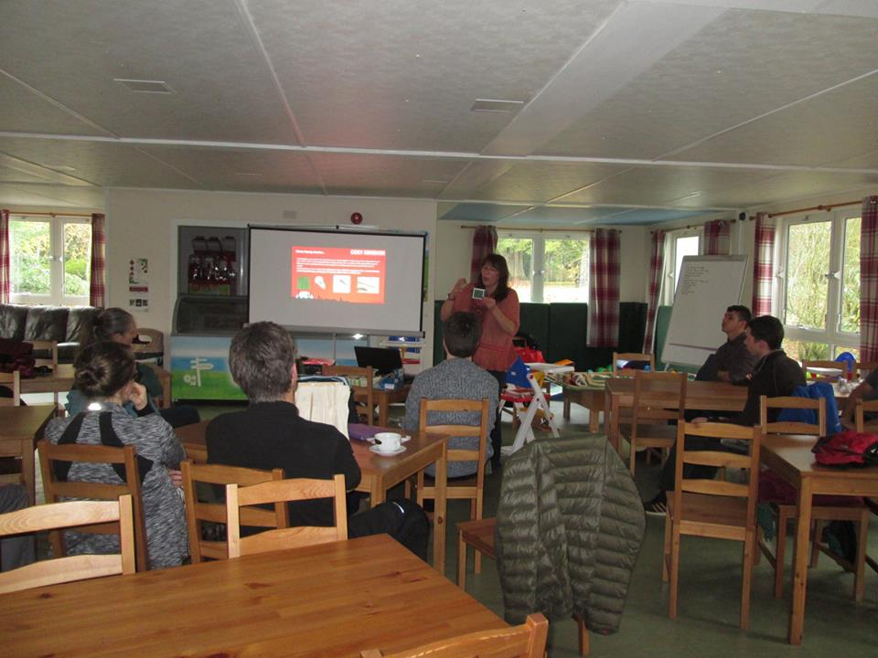
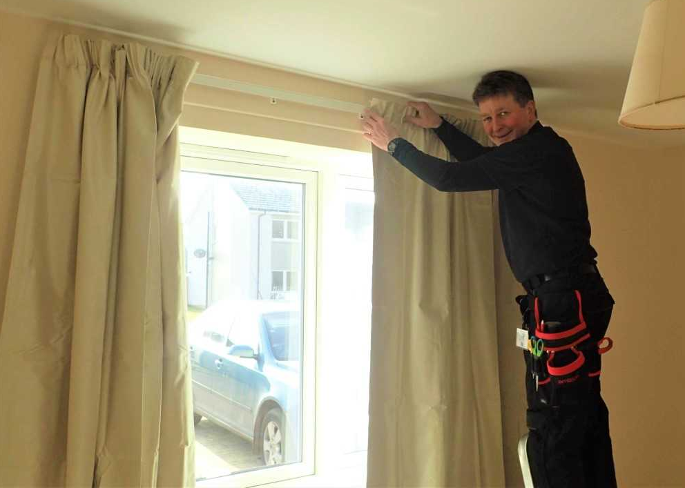
This year, StAndEN completed 479 home visits in total. Our ‘handy’ service installed measures in 244, including LED bulbs, thermal curtains and radiator panels. As a result of our intervention clients made £167,378 worth of financial gains this year. We were supported by 4 volunteers - 2 working as Energy Champions within their local areas, and 2 working within the office. We gave non in-depth advice to 740 householders through talks and events.
Throughout the year we StAndEN gave 78 talks and presentations on Cosy Kingdom and saving energy in the home.

Case Study 1:
This participant is a single male who recently moved to a Fife Council tenancy & we were asked to visit by his housing officer. He was looking for help with working his new heating system and how to use it most efficiently. Participant lives in a stone-built flat in a listed building. He was also in need of a number of basic household items which we were asked if we could provide too.
As requested, we were able to provide the him with a household pack. We spoke with the both participant & his support worker, who was also present, about the best way to keep his property warm & about avoiding using costly appliances, where possible. We explained how electric heating works (as he was used to gas central heating in his previous property) & showed him how to programme the heating to come on & go off during the day. We also encouraged he & his support worker to contact the energy provider to provide meter readings – as this hadn’t been done when the client moved into the property a few weeks previous to our visit – and to arrange a date for them to fit a smart meter as the participant was keen for this to happen. We noted that he had a very large north-facing window in his living room which had no curtains, so we measured up for these to be installed and for radiator foils and LED bulbs to be provided too.
The participant is now aware of how best to use his heating system & how to programme the timer/ make changes as and when required. Through all of the help provided, participant now feels much happier in his property and more confident in his ability to control his energy usage.

Case Study 2:
This participant is a single parent living in a terraced private rented property with her 2 young children. She was referred to Cosy Kingdom by her support worker who had said that she would benefit from advice on how best to keep her property warm over the winter months.
During our visit the participant disclosed that, due to an increase in her energy bills, she had accrued debt with her supplier. Whilst carrying out our energy audit we discovered that the participant had her heating system on at continuous which explained the change in her bills. We showed the participant how to use her programmer and helped her to set times for her heating to come on and go off, which worked best for their lifestyle. Due to the participant’s debt we were unable to change to a different supplier, but we referred (with their permission) to CARF to explore if there was help available with this. We were also able to provide the participant with a door curtain, radiator foils and LED bulbs.
The participant has since spoken with CARF who have explained her options regarding the energy debt & is following this advice. Participant now feels better about managing her energy costs & usage and is aware that if she requires any further advice or assistance that she can get back in touch.

Clean & Green, this project has come to the end of its forth year of a five year commitment from BID St Andrews. We have a team of three employed in this project and they do every thing from litter picks to hanging the flower baskets for St Andrews in Bloom. Their achievements are posted on face book weekly and the project receives a lot of favourable comments showing how it is appreciated not only by the businesses who fund it but also the wider public.
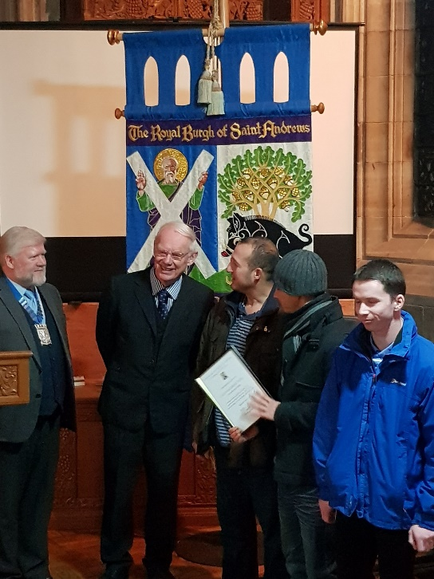
Their work which involved: beach cleans & litter picks: graffiti removal; cleaning of bins, benches and the war memorial, the fountain and Hamish; out of date poster removal; cleaning and touching up street furniture; dealing with the issues of bins in St Andrews; collecting & sorting unwanted household items which are then given to those in need within the area; providing goods and equipment to other charitable organisations (for example 30 duvets to women’s aid and crockery to the Friends of Craigtoun and the North East Fife Community Hub) ; inspecting the BID area 5 days a week and reporting any issues to Fife Council; providing support for BID and other organisations at events; provide logistical support to St Andrews in Bloom which includes hanging and placement of flower baskets and tubs; logistical support for other organisations such as St Andrews Men Shed. Transition University of St Andrews; Harbour Gala. 60% of the teams’ time is devoted to works connected to the BID Area while the other 40% is supporting other charities and responding to the issues raised by residents of the town. The Truck we have is recognised as the Town truck and moves large items for any local group. This year St Andrews Community Trust presented the team with a special award for service to the community.

Clean & Green Activity summary for the year:
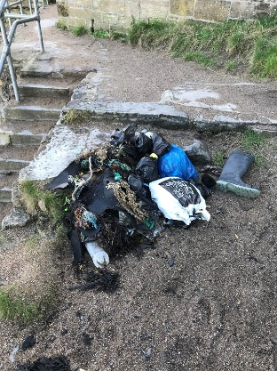
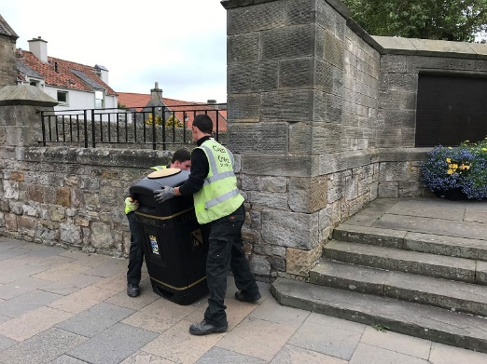
•77 new BINS (Big belly and Jubilees)
•6 beach cleans a week Castle, Bruce, and East Sands.

•Report into Coast and Countryside Trust on any palm oil lumps on the beach
•Removed and reported over 600 pieces of graffiti. 2 out the 3 prevalent graffiti individuals/groups have been caught and prosecuted using our intelligence and evidence to pin them down and gain video images. The group who are currently being prosecuted has graffiti that covers all of Fife, Dundee and Edinburgh, and has fingers crossed now stopped (SO7 group from Dundee). The third person, the images were inconclusive and is still an ongoing problem.
•Repainted 10 wooden flower butts for St Andrews in Bloom.
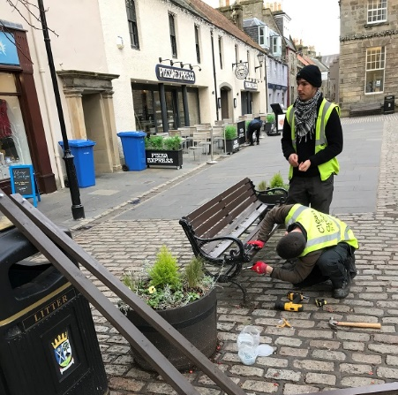
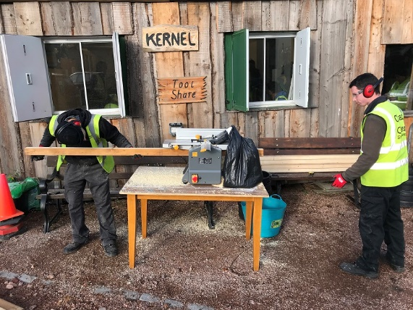
•Repaired 8 Benches in town

•Dug in paving slabs, mounted 2 metal butts at Petheram Bridge sloping bed for St Andrews in Bloom.
•Hung 147 hanging baskets and 45 wrap-around butts for St Andrews in Bloom
•Weeding along stretches of streets most notably Westport, Abbey Walk & the Harbour area
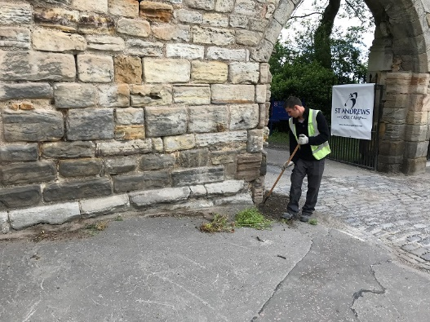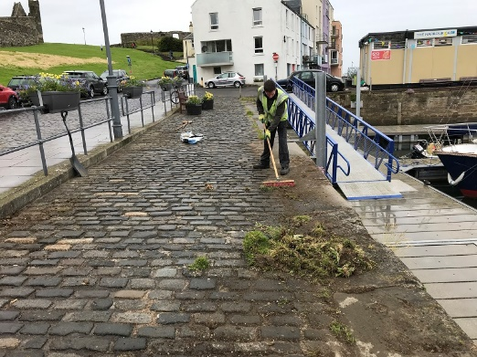
•Clean out of the fountain
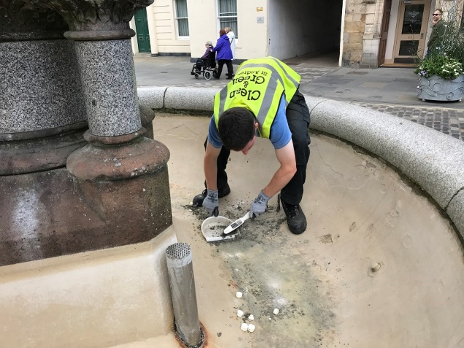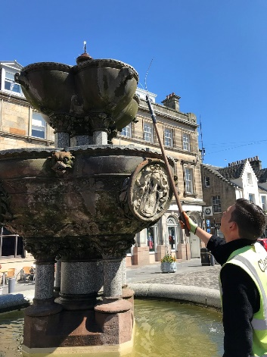
•Picked up and bagged 1260 kgs of litter this year (this does not include general daily street cleaning litter) 3 Metric Tonnes since the beginning. Now have set up a monthly town clean up where the community recommends an area locally that they would like to see given extra attention and the team are joined volunteers to clean up the area including the St Andrews Hospital Car Park.
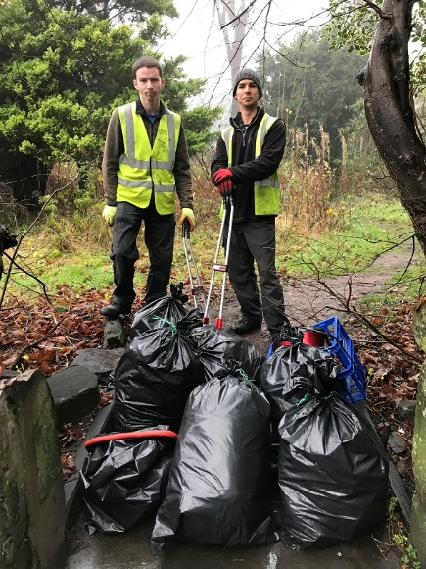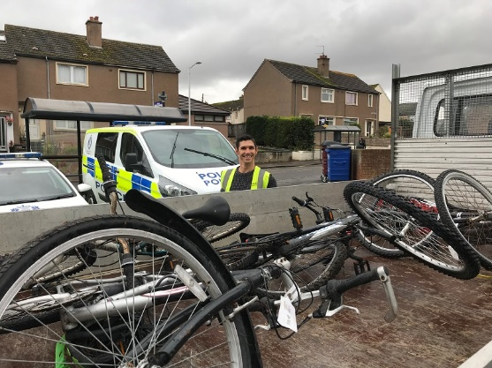
•Recovered 11 bikes and 8 shopping trolleys.
•Recovered Driftwood planks and donated Men's’ Shed.
•Been involved in 22 pickups of kit from students houses that has been reissued to those in need in a bid to reduce dumping on the streets
•Supported St Andrews University Transition with Halls of Residence clearance for reuse, around 18 truckloads, preventing dumping on streets.
•Recovered several pallets thrown out by businesses, stopping Students burning them on the beach and donated to Men's’ Shed to make garden furniture for Charities such as Stratheden Hospital or to sell and raise funds.
•Removed 40kg of nails and metal from burnt pallets and other debris at Castle beach with the Clean & Green Magnet.

Constantly returning road signs, traffic cones and business pavement furniture back to where they supposed to be. (Vermin sacks, plants, ornaments, A boards etc go walkabout during evenings and bad weather)
Daily communication with Fife Council Commercial and Domestic Waste Enforcement officers
Cleaned up and continue to clear away old masking tape and stickers from every lamp post requiring work within the BID zone.
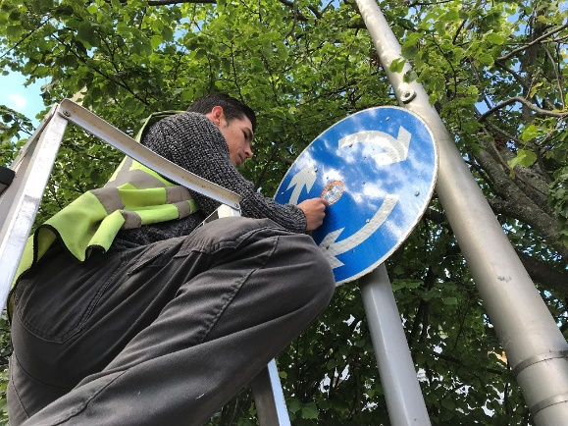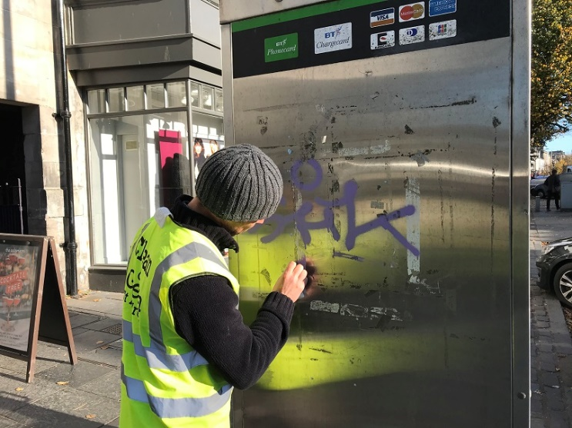
XMAS lights Bloom 4 hanging balls on lamp posts, 11 obelisks position in flower butts and recover later.
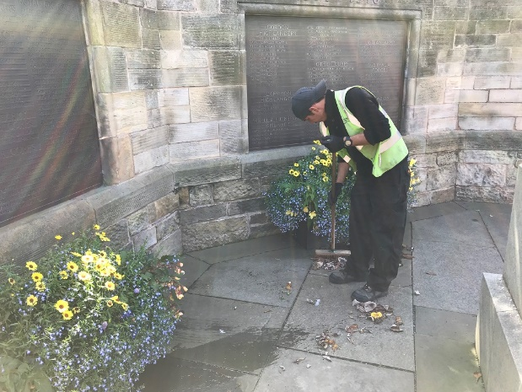
Numerous bins and benches are washed every week
Hamish the cat gets washed as required and the War Memorial gets the attention it deserves.

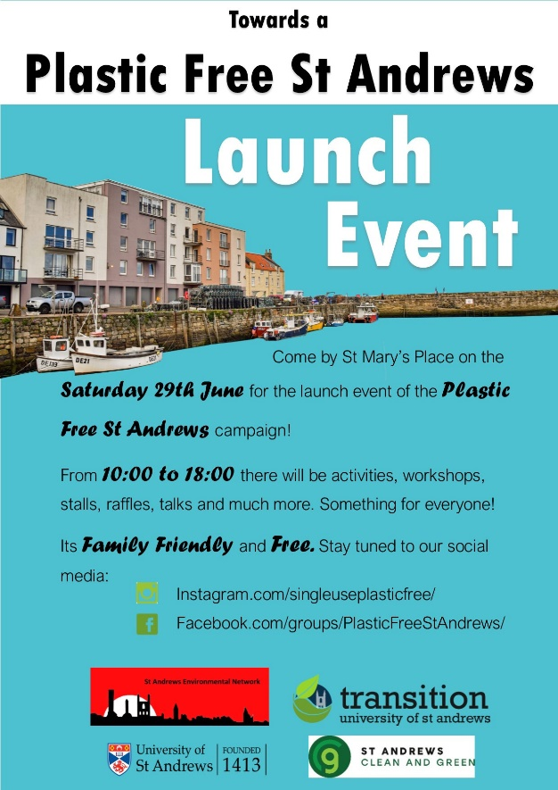
Towards a Plastic Free St Andrews, currently unfunded. This project has developed over the year and going forward it has been widened and is now Sustainable St Andrews.
Over the year we work with businesses to work towards plastic free status. On 29th June 2019 we held the formal launch of the project in the Fife Council Local Office, St Mary’s Place, St Andrews. The event was attended by over 600 people from the local community.

Agenda for the Launch Event
29 JUNE 2019, Fife Council Building, St. Mary’s Place

10am – 12noon
Workshop on ‘Raising a family plastic free’
Info stall on the ‘Towards a Plastic Free St. Andrews’ initiative
Info stall on what businesses can do to become single-use plastic free
Sustainable products available for sale
Beeswax wrap workshop
Reusing plastic containers for planting

12.30 - 3.30pm
12.30 – 1.00pm: Presentation on the ‘Towards a Plastic Free St. Andrews’ initiative – Al Clark, Environmental Officer, University of St. Andrews
1.00 – 2.00pm: Presentation on the ‘Impact of primary plastic pollution at the Firth of Forth’ by Dr. Allison Reeves & Susanne Grimes
2.00 – 2.45pm: Presentation on ‘Plastic Free Anstruther working towards gaining Plastic Free status’ Alice Pearson
3.45 – 3.30pm: Presentation on ‘Plastics Campaign by Greenpeace’ - Sally Romilly, Greenpeace Dundee Group

3.30pm – 4.15pm
Awards ceremony to businesses which have achieved SAS objectives towards becoming single-use plastic free:

Cromar’s Restaurant
The Cheesy Toast Shack
The Golf Museum Café
The Cottage Garden
Combini
Costa Coffee
St. Andrews Brewing Company

4.15 – 4.30pm
Quiz

4.30pm – 5pm
Raffle prizes will be announced

5 – 6pm
Info stall on the ‘Towards a Plastic Free St. Andrews’ initiative
Info stall on what businesses can do to become single-use plastic free
Sustainable products available for sale

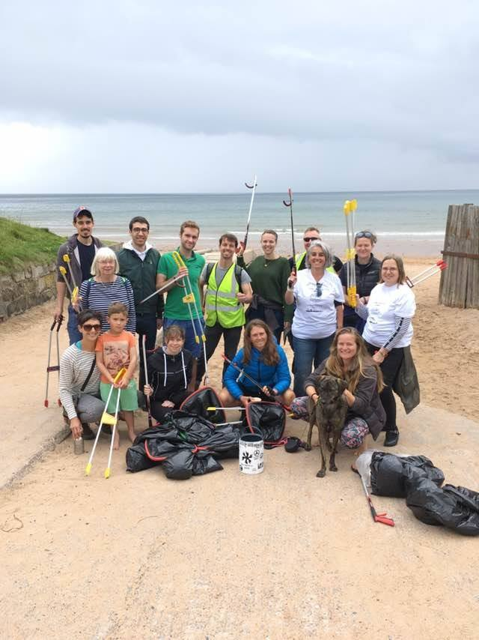
On Saturday 13th July Kiko Matthews as part of Kik-Plastic 2019 visited St Andrews as part of her epic journey round Britain’s Coastline to raise awareness of the problem of single-use plastic and engage communities to help tackle it. She was joined by volunteers from the local community after the call went out from the “Towards a Plastic Free St Andrews” campaign.
The seventeen volunteers from all age groups joined Kiko’s team and removed 15kgs of waste from the East Sands in an hour and a half.

In December 2019 we submitted our application to become a plastic free town however the criteria changed and we had to resubmit. We still had not received the “Plastic Free” status at the end of March.

